Maintenance

🌟 Definition
# Source: AI Source: Provided by: [Data Path: Persons Table -> ID Column: 1, Name_En Column: Motasem Essam] -> From: [ChatGPT] on [1/23/2026]
Maintenance is the seventh and final phase of the Software Development Life Cycle (SDLC) where the deployed software is monitored, supported, updated, and improved after it goes live.
The main question in this phase is:
"How do we keep the software working effectively after deployment?"

🎯 Purpose of Maintenance Phase
# Source: AI Source: Provided by: [Data Path: Persons Table -> ID Column: 1, Name_En Column: Motasem Essam] -> From: [ChatGPT] on [1/23/2026]
The goals of maintenance are to:
- Fix bugs found after release
- Improve performance
- Enhance security
- Add new features
- Adapt to changing business needs
- Ensure system stability and reliability

🔄 Maintenance Process
# Source: AI Source: Provided by: [Data Path: Persons Table -> ID Column: 1, Name_En Column: Motasem Essam] -> From: [ChatGPT] on [1/23/2026]
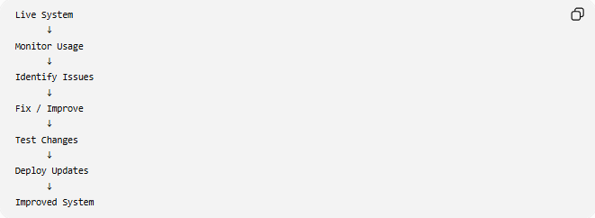
Live System
↓
Monitor Usage
↓
Identify Issues
↓
Fix / Improve
↓
Test Changes
↓
Deploy Updates
↓
Improved System

🧩 Main Activities in Maintenance

1️⃣ Bug Fixing
# Source: AI Source: Provided by: [Data Path: Persons Table -> ID Column: 1, Name_En Column: Motasem Essam] -> From: [ChatGPT] on [1/23/2026]
Definition
Correct defects discovered after deployment.

Example
Issue:
Users cannot reset passwords.
Solution:
Fix password reset functionality.

2️⃣ Performance Optimization
# Source: AI Source: Provided by: [Data Path: Persons Table -> ID Column: 1, Name_En Column: Motasem Essam] -> From: [ChatGPT] on [1/23/2026]
Definition
Improve system speed and efficiency.

Examples:
- Optimize database queries
- Reduce page load times
- Improve API response times
- Increase scalability

Example:
Before:
Page Load Time: 8 Seconds
After Optimization:
Page Load Time: 2 Seconds

3️⃣ Security Updates
# Source: AI Source: Provided by: [Data Path: Persons Table -> ID Column: 1, Name_En Column: Motasem Essam] -> From: [ChatGPT] on [1/23/2026]
Definition
Protect the system against new vulnerabilities and threats.

Examples:
- Patch security flaws
- Update dependencies
- Improve authentication
- Strengthen encryption

Example:
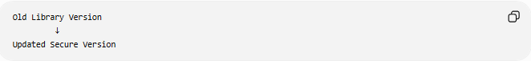
Old Library Version
↓
Updated Secure Version

4️⃣ Feature Enhancements
# Source: AI Source: Provided by: [Data Path: Persons Table -> ID Column: 1, Name_En Column: Motasem Essam] -> From: [ChatGPT] on [1/23/2026]
Definition
Add new functionality requested by users or businesses.

Example:
Original System:
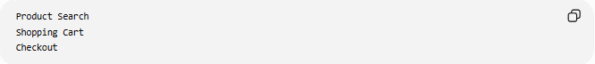
Product Search
Shopping Cart
Checkout

New Requirement:
Add Wishlist Feature

5️⃣ System Monitoring
# Source: AI Source: Provided by: [Data Path: Persons Table -> ID Column: 1, Name_En Column: Motasem Essam] -> From: [ChatGPT] on [1/23/2026]
Definition
Continuously monitor system health and usage.

Monitor:
- Server performance
- Database performance
- Application errors
- User activity
- Security events

Example:
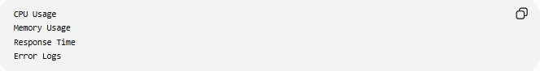
CPU Usage
Memory Usage
Response Time
Error Logs

6️⃣ Backup and Recovery
# Source: AI Source: Provided by: [Data Path: Persons Table -> ID Column: 1, Name_En Column: Motasem Essam] -> From: [ChatGPT] on [1/23/2026]
Definition
Protect data against loss or corruption.

Process:
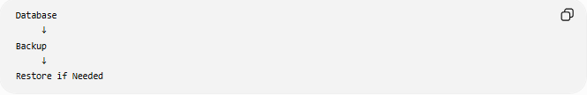
Database
↓
Backup
↓
Restore if Needed

Examples:
- Daily backups
- Weekly backups
- Disaster recovery plans

7️⃣ User Support
# Source: AI Source: Provided by: [Data Path: Persons Table -> ID Column: 1, Name_En Column: Motasem Essam] -> From: [ChatGPT] on [1/23/2026]
Definition
Assist users with problems and questions.

Examples:
- Help desk support
- Technical support
- Documentation updates
- Training materials

📚 Types of Maintenance

1️⃣ Corrective Maintenance
# Source: AI Source: Provided by: [Data Path: Persons Table -> ID Column: 1, Name_En Column: Motasem Essam] -> From: [ChatGPT] on [1/23/2026]
Definition
Fix existing defects and bugs.

Example:
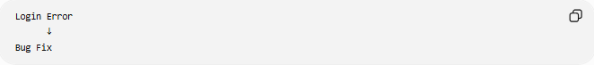
Login Error
↓
Bug Fix

2️⃣ Adaptive Maintenance
# Source: AI Source: Provided by: [Data Path: Persons Table -> ID Column: 1, Name_En Column: Motasem Essam] -> From: [ChatGPT] on [1/23/2026]
Definition
Modify software to work in a new environment.

Examples:
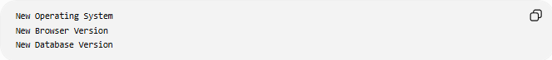
New Operating System
New Browser Version
New Database Version

3️⃣ Perfective Maintenance
# Source: AI Source: Provided by: [Data Path: Persons Table -> ID Column: 1, Name_En Column: Motasem Essam] -> From: [ChatGPT] on [1/23/2026]
Definition
Improve performance or add enhancements.

Examples:
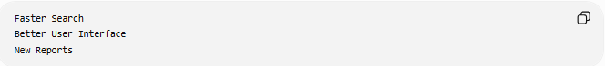
Faster Search
Better User Interface
New Reports

4️⃣ Preventive Maintenance
# Source: AI Source: Provided by: [Data Path: Persons Table -> ID Column: 1, Name_En Column: Motasem Essam] -> From: [ChatGPT] on [1/23/2026]
Definition
Prevent future issues before they occur.

Examples:
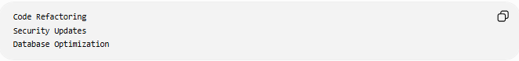
Code Refactoring
Security Updates
Database Optimization

📊 Types of Maintenance Comparison
# Source: AI Source: Provided by: [Data Path: Persons Table -> ID Column: 1, Name_En Column: Motasem Essam] -> From: [ChatGPT] on [1/23/2026]
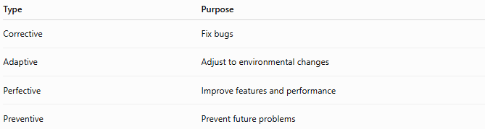
Type | Purpose
Corrective | Fix bugs
Adaptive | Adjust to environmental changes
Perfective | Improve features and performance
Preventive | Prevent future problems

🛠️ Tools Used in Maintenance
# Source: AI Source: Provided by: [Data Path: Persons Table -> ID Column: 1, Name_En Column: Motasem Essam] -> From: [ChatGPT] on [1/23/2026]
Monitoring Tools
- Grafana
- Prometheus

Issue Tracking
- Jira

Version Control
- Git

Logging Tools
- Elasticsearch
- Kibana

📄 Maintenance Deliverables
# Source: AI Source: Provided by: [Data Path: Persons Table -> ID Column: 1, Name_En Column: Motasem Essam] -> From: [ChatGPT] on [1/23/2026]
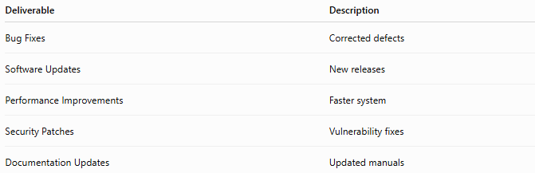
Deliverable | Description
Bug Fixes | Corrected defects
Software Updates | New releases
Performance Improvements | Faster system
Security Patches | Vulnerability fixes
Documentation Updates | Updated manuals

📊 Output of Maintenance
# Source: AI Source: Provided by: [Data Path: Persons Table -> ID Column: 1, Name_En Column: Motasem Essam] -> From: [ChatGPT] on [1/23/2026]
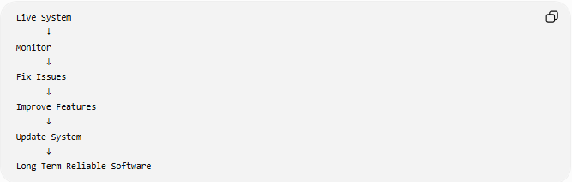
Live System
↓
Monitor
↓
Fix Issues
↓
Improve Features
↓
Update System
↓
Long-Term Reliable Software

🌍 Real-World Example
# Source: AI Source: Provided by: [Data Path: Persons Table -> ID Column: 1, Name_En Column: Motasem Essam] -> From: [ChatGPT] on [1/23/2026]
Online Shopping Website
After deployment:
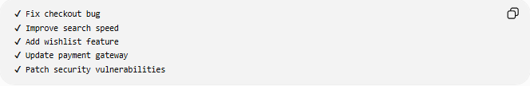
✔ Fix checkout bug
✔ Improve search speed
✔ Add wishlist feature
✔ Update payment gateway
✔ Patch security vulnerabilities
The website continues to evolve and improve.

🧠 Simple Analogy
# Source: AI Source: Provided by: [Data Path: Persons Table -> ID Column: 1, Name_En Column: Motasem Essam] -> From: [ChatGPT] on [1/23/2026]
Building a house:
After Moving In
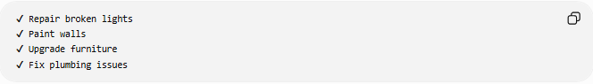
✔ Repair broken lights
✔ Paint walls
✔ Upgrade furniture
✔ Fix plumbing issues
The house requires ongoing care.
Software is the same:
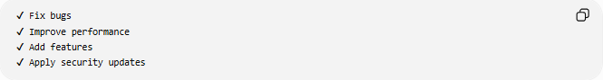
✔ Fix bugs
✔ Improve performance
✔ Add features
✔ Apply security updates
to keep it useful and reliable.

🧭 Summary
# Source: AI Source: Provided by: [Data Path: Persons Table -> ID Column: 1, Name_En Column: Motasem Essam] -> From: [ChatGPT] on [1/23/2026]
The Maintenance Phase is the final stage of the SDLC where software is continuously monitored, supported, corrected, and improved after deployment. It includes bug fixes, performance enhancements, security updates, feature additions, monitoring, backups, and user support. Maintenance ensures that the software remains reliable, secure, efficient, and aligned with changing business and user needs throughout its lifecycle.

